Supporting Information for:

**Water temperature controls for regulated canyon-bound rivers**

Bryce A. Mihalevich 1, Bethany T. Neilson 1, Caleb A. Buahin 1, Charles Yackulic 2, John C. Schmidt 3

1 Utah Water Research Laboratory, Department of Civil and Environmental Engineering, Utah State University, 8200 Old Main Hill, Logan, Utah, 84322-8200, United States

2 U.S. Geological Survey, Southwest Biological Science Center, Grand Canyon Monitoring and Research Center, 2255 N. Gemini Dr., Flagstaff, AZ 86001, United States

3 Department of Watershed Sciences, Utah State University, 8200 Old Main Hill, Logan, Utah 84322-8200, United States

# Contents of this file

Text S1 to S6

Figures S1 to S12

Tables S1 to S4

# Introduction

The information in this document provides additional detail about historical conditions in Grand Canyon, equations used for determining the diffuse fraction of shortwave radiation, and about the assumptions made about meteorological data.

# Text S1: Heat from lateral inflows

In order for lateral inflow contributions to be comparable with other heat fluxes, the energy contributed from tributaries (*Jtrib*) and distributed inflows (*Jdist*) was calculated as the apparent sensible heat flux (Kurylyk et al., 2016). This approach uses the main channel temperature as a relative thermal datum allowing for the influence of lateral inflows on instream temperature to be quantified. The formulation for this approach is:

|  |  |  |
| --- | --- | --- |
|  | $$J_{lat,c}=J_{trib,c}+J_{dist,c}$$ | (S1) |
|  | $$J_{trib,c}=\frac{ρ_{w}c_{p}Q_{trib,c}(T_{trib,c}-T_{c})}{A_{s,c}}$$ | (S2) |
|  | $$J_{dist,c}=\frac{ρ_{w}c_{p}Q_{dist,c}(T_{dist,c}-T_{c})}{A_{s,c}}$$ | (S3) |

where (*c*) is the model cell index, *Jlat,c*, *Jtrib,c*, *Jdist,c* is the heat flux (positive or negative) being contributed to the model cell (W/m2), *Qtrib*is the external flow from a tributary (m3/s), *Qdist* is the distributed flow (m3/s), *Ttrib* is the tributary temperature (°C), *Tdist* is the distributed flow temperature (°C; assumed to be the mean annual air temperature from within Grand Canyon, Table S3), *Tc* is the water temperature of the model cell (°C), *ρw* is the water density (kg/m3), *cp* is the specific heat capacity of water (J/kg/°C), and *As,c* is the surface area (m2) of the model cell.

# Text S2: Fraction of diffuse shortwave radiation

Measured shortwave radiation outside of the canyon was disaggregated into direct (${\hat{J}}_{sn,dir}$) and diffuse (${\hat{J}}_{sn,diff}$) components using a correlation equation that predicts the fraction of diffuse radiation (*kd*; Eqn. 7) based on the clearness index (*kt*; Eqn. 6). The correlation equations tested include:

Erbs et al. (1982):

|  |  |  |
| --- | --- | --- |
|  | $$k_{d}=\left\{\begin{aligned}1-0.09k_{t}, &k_{t}≤0.22 \\ 0.9511-0.1604k_{t}+4.39k_{t}^{2}-16.64k_{t}^{3}+12.34k_{t}^{4}, &{0.22<k}_{t}≤0.80 \\ 0.165, &k_{t}>0.80\end{aligned}\right.$$ | (S4) |

Orgill & Hollands (1977):

|  |  |  |
| --- | --- | --- |
|  | $$k_{d}=\left\{\begin{aligned}1-0.249k_{t}, &k_{t}≤0.35 \\ 1.577-1.84k_{t}, &{0.35<k}_{t}≤0.75 \\ 0.177, &k_{t}>0.75\end{aligned}\right.$$ | (S5) |

Lam & Li (1996):

|  |  |  |
| --- | --- | --- |
|  | $$k_{d}=\left\{\begin{aligned}0.977, &k_{t}≤0.15 \\ 1.273-1.361k_{t}, &{0.15<k}_{t}≤0.70 \\ 0.273, &k_{t}>0.70\end{aligned}\right.$$ | (S6) |

# Text S3: Shading algorithm

Our approach to computing spatiotemporal shade factors is based on the procedure described by Yard et al. (2005), but modified slightly so that the entire shortwave radiation spectrum can be scaled. The first step computes elevation angles (*Ψ*E; Figure 1) at locations spaced every 100 m along the river centerline. *Ψ*E is defined as the largest angle measured from the water surface to the highest topographic feature. At each point, *Ψ*E is determined at 1° increments over a 360° azimuth circle using a 10-m resolution digital elevation model (DEM) clipped to a 10-km buffer of the river centerline. This process returns a matrix containing 360 *Ψ*E values for every location along the river centerline. The second step computes solar geometries of zenith angles (*θ*) and azimuth angles (*Φ*) for each location at 15-minute increments for each day of the year using the Modular Distributed Watershed Educational Toolbox (MOD-WET; (Huning & Margulis, 2015). For each time step (*t*), the algorithm returns *Ψ*E in the direction of *Φ*, interpolating when needed. Because *Ψ*E is based on a different datum than *θ*, *Ψ*E is subtracted from 90° to get an angle measured from the vertical datum, referred to as illumination angle (*Ψ*I). *Ψ*I is then compared directly to *θ* at time *t* (i.e., *θt*), where *Ψ*I > *θt* indicates no shade and *Ψ*I < *θt* indicates shade. This results in a binary matrix where each *x,y* location has a time series of Boolean values that can be repeated for any year. Lastly, the binary values are averaged over space for their respective model cell (typically 1-km long) resulting in a shade factor (*Sf,c*) that represents the fraction of a cell being shaded at a given time.

# Text S4: Fluid friction flux

Heat generated through internal fluid friction was not in the original channel solute and heat (CSH) component of HydroCouple. We adapted the CSH component to include this heat flux by following the formulation by Theurer et al. (1984) as:

|  |  |  |
| --- | --- | --- |
|  | $$J_{f}=9805 Q \frac{S}{B}$$ | (S7) |

where *Jf* is the fluid friction flux (W/m2), *Q* is the stream discharge (m3/s), *S* is the stream gradient, and *B* is the channel top width (m).

# Text S5: Background on the Colorado River in Grand Canyon

The completion of Glen Canyon Dam (GCD) in 1963 and subsequent filling of Lake Powell has significantly affected the downstream aquatic environment because the Colorado River’s flow regime through Grand Canyon is entirely determined by releases from the reservoir. The annual release schedule is set by the Law of the River, which is the informally named assemblage of bi-national treaties, interstate compacts, federal laws, administrative agreements, and records-of-decision associated with environmental impact statements. In the Colorado River basin, water volumes are commonly measured and reported in million acre-feet (MAF). Annual releases are managed to be 8.23 MAF (322 m3/s), but can vary year-to-year depending on operational tiers established by the 2007 interim guidelines (U.S. Department of the Interior, 2007). Monthly and daily reservoir releases are primarily determined by regional demands for hydroelectricity generated at the large dams and agreements that restrict the efficiency of hydropower production in order to minimize adverse impacts to downstream ecosystems. In the Colorado River network, the largest demands for hydroelectricity are in winter and summer, and the lowest demands are in spring and fall (Wright et al., 2005). Consequently, in the Grand Canyon, monthly total streamflow is typically largest in December, January, July, and August.

In addition to the changes in the flow and sediment supply regimes that have been extensively described (e.g., Grams et al., 2015; Topping et al., 2000, 2003), regulation has also dramatically changed the thermal regime of the Colorado River from a seasonally warm river in summer to a predominantly cold river in summer (Vernieu et al., 2005). The Colorado River once had ice on its surface in some places during winter, but this no longer occurs. Pre-dam temperatures of the Colorado River at Lees Ferry (Figure 2) averaged 14 °C, ranging from 0 °C to 27 °C (Anderson & Wright, 2007; Vernieu et al., 2005). Since 1980, when the reservoir reached capacity for the first time, temperatures at Lees Ferry have averaged 10.3 °C, ranging from 7.0 °C to 16.5 °C. Colder downstream temperatures in the post-dam era are due to penstock withdrawals from the hypolimnion, which maintains temperatures between 6 °C and 9 °C when the reservoir is relatively deep (Vernieu et al., 2005; Figure S12). Instead of the warmest river temperatures occurring in July or August, as was the case in the pre-dam era, downstream temperatures are now highest between October and December when reservoir levels are generally lower and fall turnover mixes the relatively warm epilimnion with the hypolimnion. For instance, the warmest temperature at Lees Ferry (16.5 °C) occurred in October of 2005, coinciding with the lowest reservoir levels in Lake Powell since filling. Seasonal river temperature patterns still exist today, however, releases from the relatively stable hypolimnion has greatly reduced the annual variation (Vernieu et al., 2005; Figure S12). Several endemic fish species from Grand Canyon, including two federally listed fish species (i.e., humpback chub (*Gila cypha*) and razorback sucker (*Xyrauchen texanus*) and three extirpated fish species (i.e., Colorado pikeminnow (*Ptychocheilus lucius*), roundtail chub (*Gila robusta*) and bonytail chub (*Gila elegans*), have declined in response to introduction of non-native fish and the direct impacts of the current regulated flow and post-dam water temperature regime.

Many datasets have also been published for Grand Canyon due to the need to understand the aquatic ecosystem within the national park, making the region very data rich. Flow measurements at Lees Ferry and above Bright Angle Creek (approximately 141 km downstream) started in the early 1920’s. Additional main channel gages were established decades later in the 1980’s. Continuous measurements of river temperature began in the early 1990’s with 10 stations spaced approximately 50 km apart. Tributaries to the Colorado River have also been monitored to provide flow, water temperature, and sediment flux data. Main channel and tributary data have been used to inform and evaluate experimental reservoir releases (unrelated to hydropower production) implemented to improve beaches for recreational users and benefit fish populations. One implementation of this was during the summer of 2000 and fall of 2001, where low steady flows were released to raise summer river temperature to benefit native fish (Schmidt et al., 2007; Trammell et al., 2002). In the mid 2000’s the number of main channel and tributary monitoring sites were reduced. Currently, active monitoring includes five main channel flow gaging sites, 9 main channel water temperature sites, and 5 tributary sites recording flow and water temperature measurements (Figure 2; Table S1). More information about monitoring efforts can be found in Vernieu et al. (2005) and data can be obtained from the US Geological Survey Grand Canyon Monitoring and Research Center (GCMRC; www.gcmrc.gov).

In addition to the rich amount of data associated with the Colorado River, extensive weather data from within Grand Canyon and surrounding region also exist. Meteorological observations of air temperature and precipitation have been recorded at daily and sub-daily resolution as part of the National Weather Service Cooperative Observer (COOP) network at Lees Ferry since 1928, in Phantom Ranch (located approximately 1 km upstream from the main channel in Bright Angle Creek) since 1935, and at Page, Arizona since 1957 (Figure 2; Caster & Sankey, 2016). Additional parameters of wind speed and relative humidity were added to these sites at later dates. Weather data has also been collected by the GCMRC within Grand Canyon at the river elevation intermittently since 2003 to relate geomorphic changes to meteorological events (Caster et al., 2014; Draut & Rubin, 2006). Along the north and south rim of Grand Canyon are several weather stations that are part of the wildland fire remote automated weather station (RAWS) network. Some RAWS network sites have existed since the early 1990’s and are to our knowledge, the only sources for sub-daily shortwave radiation measurements within the region (Figure 2; Table S4).

Accompanying the extensive amount of data for the Grand Canyon region are models to estimate Colorado River flow, river temperature, sediment transport, and bioenergetics downstream of GCD. The first river temperature model, motivated by the need to determine the influence of water release temperatures from GCD on downstream river temperatures, looked into the effect of a multi-level penstock withdraw structure to warm reservoir releases and promote downstream warming (Ferrari, 1987). They found that warming would occur, but not to pre-dam levels. The addition of a temperature control device (TCD) at GCD has been the subject of many subsequent studies (Garrett et al., 2003; Petersen & Paukert, 2005; U.S. Bureau of Reclamation, 1999). Anderson and Wright (2007) developed a temperature model to explore the effects of dam operations on the downstream thermal regime at an hourly time step. Their model was based on the equilibrium temperature concept, which is the water temperature reached when the sum of the heat fluxes across the air–water interface equals zero (Buendia et al., 2015; Edinger et al., 1968). Anderson and Wright (2007) used Lake Powell release flow and water temperature, air temperature, and wind speed as model inputs. To account for longitudinal dispersion of flow velocities in Grand Canyon (Graf, 1995), they used the unsteady-flow model from Wiele and Griffin (1997). Their key finding was that flow volumes play the most substantial role in determining water temperature patterns downstream. Later, Wright et al. (2009) created a less sophisticated version of the Anderson & Wright (2007) model, estimating river temperature at a monthly time step to allow for simplified evaluations of alternative dam operations considered by the Glen Canyon Adaptive Management Program (GCDAMP). Most recently, Valdez et al. (2013) assessed the effects of adding a TCD to Glen Canyon Dam on downstream river temperatures, similar to Ferrari (1987), but also looked at potential water temperature effects on native and nonnative fish species.

# Text S6: Excluded heat transfer mechanisms

Other mechanisms could be explored and potentially incorporated within the model in order to improve temperature predictions. Additionally, investigation of model residuals at sub-daily time scales may provide further insight into missing or misrepresented processes. These include groundwater exchanges, hyporheic exchange, surface transient storage, and time-varying albedo. While each of these processes likely occur to some degree, these were ultimately left out of the model because they were expected to be negligible based on findings in the literature or site specific conditions. For example, groundwater exchange could be occurring in portions of the Grand Canyon, particularly where the river flows over or is adjacent to karst limestone layers (e.g., Redwall Limestone and Muav Limestone formations; Huntoon, 1974; Leeder, 2010) which occur in both upper and lower segments within the canyon. However, these exchanges are likely minimized by the surrounding bed rock and the sensitivity analysis of *Qdist* suggests that further efforts along these lines may not be warranted.

Exchange of surface water with banks and sandbars could be another mechanism as water levels fluctuate in response hydropeaking operations. This results in infiltration into sandbars during the rising limb and a slower exfiltration out of the sandbars after the peak of the flow wave passes over long distances downstream (Alvarez & Schmeeckle, 2013; Budhu & Gobin, 1995; Ferencz et al., 2019; Sabol & Springer, 2013). This exchange of water between the river and sandbars within Grand Canyon does influence temperatures within these shallow aquifers (Carpenter et al., 1995). However, when water seeps back into the river as river water levels decrease, there are only small thermal gradients (< 0.2 °C) between the near shore and main channel temperatures (Ross & Vernieu, 2013). This suggests that these exchanges likely add negligible amounts of heat to the river.

Influences from surface transient storage could be occurring when backwater areas fill during high flows and drain during low flows. These areas are prominent throughout the Grand Canyon and differentially warm compared to the temperatures in the main channel because they typically have low-velocity flows and are intermittently isolated from the river (Behn et al., 2010; Trammell et al., 2002). Work has been done to evaluate water temperatures in these nearshore environments (Hoffnagle, 2001; Trammell et al., 2002; Vernieu & Anderson, 2013), however, it is not clear if there are large enough volumes of water in these areas relative to that in the main channel to result in significant heating to the river. Furthermore, these influences likely decrease downstream as the amplitude of the hydropeaking wave, backwater inundation, and total amount of volume exchanged decreases.

Lastly, variability in water surface albedo over space and time could change the radiation balance, but was not considered here. Albedo changes throughout each day as a function of the solar zenith angle with greater albedo values occurring when the sun is close to the horizon (high zenith angle; Hoch & Whiteman, 2010; Matzinger et al., 2003). Given the interference of the steep canyon walls when solar zenith angles are high, the periods of high reflection were not a factor. The times when the river receives *Jsn,dir* during the middle of the day, the zenith angles are low and the reflection off the water surface is limited when dealing with relatively clear water. In settings like the Colorado River, however, high turbidity can influence the amount of solar radiation that is reflected off the water surface (e.g., Neilson et al. 2009) and will change the amount of *Jsn,net* absorbed by the river (e.g., McMahon & Moore, 2017). Some additional work regarding the influences of the temporal and spatial turbidity patterns on solar radiation reflection throughout the Grand Canyon would be warranted.

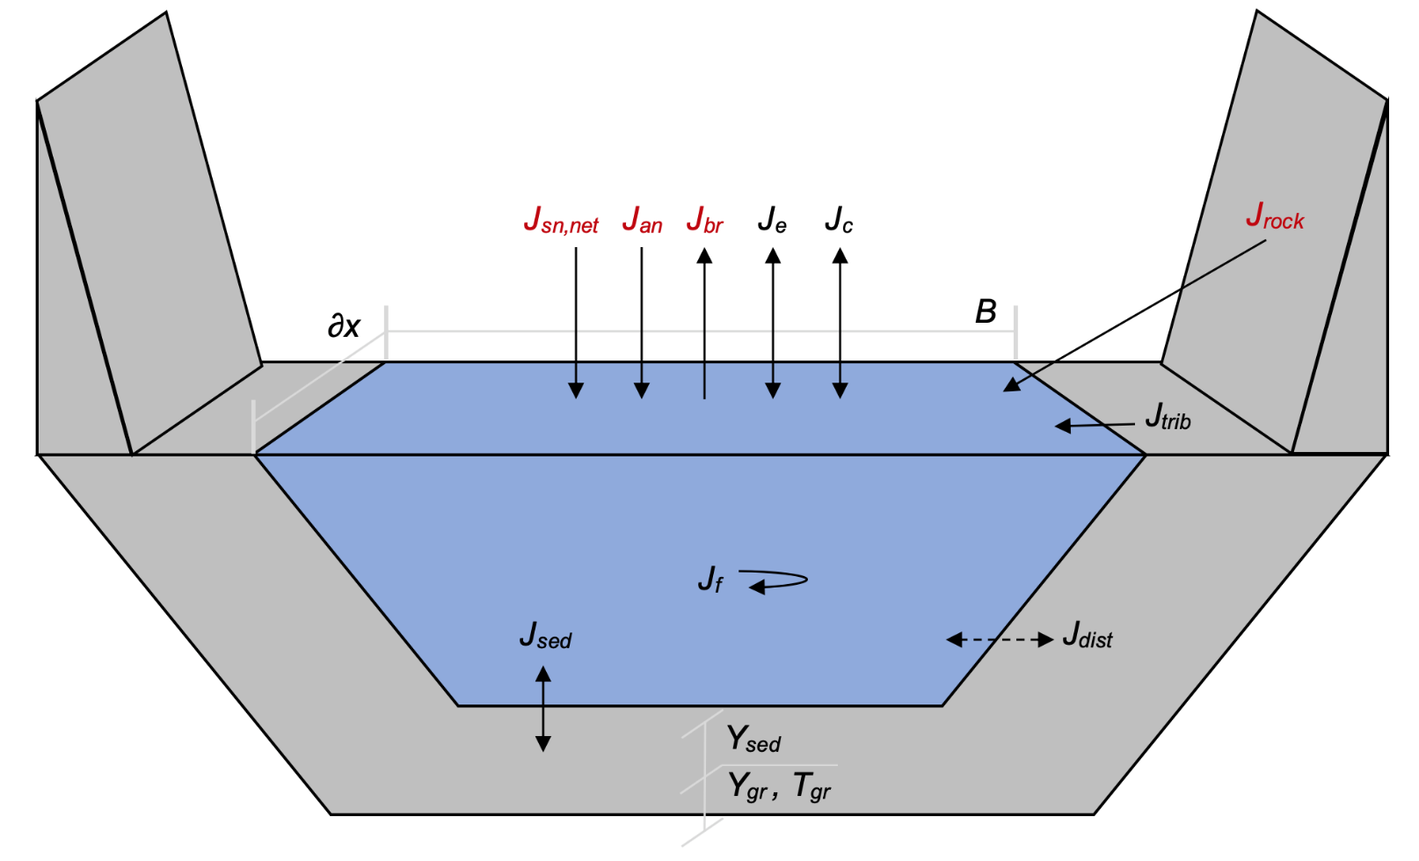

# Figure S1. Simple schematic of external heat fluxes and lateral inflows accounted for in the river temperature model. Included terms are net shortwave radiation (*Jsn,net*), atmospheric longwave radiation (*Jan*), water longwave radiation (*Jbr*), bedrock longwave radiation (*Jrock*), sensible heat (conduction and convection; *Jc*), latent heat (evaporation and condensation; Je), internal fluid shear friction (*Jf*), sediment conduction (*Jsed*), tributary flows (*Jtrib*) and distributed flows (*Jdist*). Radiative terms are shown in red (*Jsn,net*, *Jan*, *Jbr*, and *Jrock*) and are described and illustrated in greater detail in the manuscript. *Ysed* is the depth of the shallow sediment layer, and *Ygr* is the depth to the ground boundary layer. *Tsed* is the temperature of the shallow sediment layer and *Tgr* is the temperature of the ground boundary layer.



# Figure S2. Flow gained per water year in Grand Canyon between Lees Ferry (RM0) and RM225. The mean annual intervening flow is 30.4 m3/s. The contribution from gaged tributaries is roughly half, with a mean annual flow of 14.6 m3/s.



# Figure S3. Comparison between monthly average air temperature at Page, AZ municipal airport and Phantom Ranch within Grand Canyon to illustrate the general difference between the two locations (A). Relationship between sub-hourly air temperature measured at Phantom Ranch and air temperature regressed to Phantom Ranch using measured air temperature at Page, AZ (B). Histogram of residuals between measured and regressed air temperature data (C). The residuals have a mean of 0.0 and a standard deviation of 3.02 °C. The 99% confidence interval of the residuals are ± 0.012 °C.

C:\Users\Echo\Documents\ColoradoRiverBasin\Matlab\Colorado_River_Basin\Presentations\GC_temp_model_paper\Supplemental\shortwave_comparison\shortwave_compare.tif

# Figure S4. Comparison of all shortwave radiation measurements from remote automated weather station network sites (grey lines) within the Grand Canyon region over a 5-day period. The Page, AZ municipal airport weather station characterizes the first two days as being overcast with light to moderate rain. The third day was mostly clear with periods of cloud cover. The last two days were clear conditions.



# Figure S5. Plot of long-term observations and model predictions of discharge at five gaging stations within Grand Canyon (RM30, RM61, RM88, RM167, and RM225). The right panels show the distribution of residuals between observed and modeled discharge in cubic meters per second.



# Figure S6. Plot of long-term observations and model predictions of temperature at five gaging stations within Grand Canyon (RM30, RM61, RM88, RM167, and RM225). The right panels show the distribution of residuals between observed and modeled temperature.



# Figure S7. Boxplot of temperature model residuals for simple and detailed radiation schemes by month for five gaging stations within Grand Canyon. Colors correspond to the median value of a box where blue color/positive values represent model underestimated temperatures and red color/negative values represent over estimated temperatures.



# Figure S8. Illustration of calculated elevation angles (*Ψ*E) from Glen Canyon Dam (24.1 km upstream of Lees Ferry) to Spencer Creek (395.9 km downstream of Lees Ferry) that were used to calculate spatiotemporal topographic shading (see Text S2) (A). Shading factors (*Sf*) for each model cell at hourly resolution over a 1-year period used to scale incoming shortwave radiation (${\hat{J}}_{sn,dir}$) using Eqn. 8 (B). A shade factor of zero indicates no direct shortwave radiation. Note that 15-minute resolution *Sf* was used in the temperature model (i.e., Text S2).

C:\Users\Echo\Neilson Research Dropbox\Projects\ColoradoRiverBasinProject\Matlab\Colorado_River_Basin\Presentations\GC_temp_model_paper\HeatFluxStatisticsTable\lowFlow_highFlow_pieChart_meanFlux.tif

# Figure S9. Pie charts comparing the relative contribution of external heat fluxes from the detailed model during the entire simulation period (A), the summer of 2000 low flow period (B) and the summer of 2011 high flow period during (C). Variables being compared are net shortwave radiation (*Jsn,net*), net longwave radiation (*Jlw,net*), latent heat (*Je*), sensible heat (*Jc*), friction (*Jf*), bed conduction (*Jsed*), and heat from lateral sources (*Jlat*). Percent contributions are calculated from the absolute value of the average for each flux over space and time. Each pie represents the fraction of the total heat exchanged, with *Jlw,net* and *Je* having negative average fluxes for each period shown.

C:\Users\Echo\Neilson Research Dropbox\Projects\ColoradoRiverBasinProject\Matlab\Colorado_River_Basin\Presentations\GC_temp_model_paper\Sensitivity\waterTemperature_sensitivity_season_v7_spring_fall_v2.tif

# Figure S10. Sensitivity analysis of river temperature to input data perturbations at three locations during Fall and Spring averaged over the entire simulation time (Spring = Mar.-May, Fall = Sep.-Nov.). The residual is calculated as the detailed model minus scenario. Variables being compared are net shortwave radiation (*Jsn,net*), air temperature (*Tair*), bedrock temperature (*Trock*), upstream boundary flow (*QBC*), upstream boundary condition temperature (*TBC*), relative humidity (RH), wind speed (WS), distributed flows (*Qdist*), distributed flow temperatures (*Tdist*). Box plot order follows that of the legend.

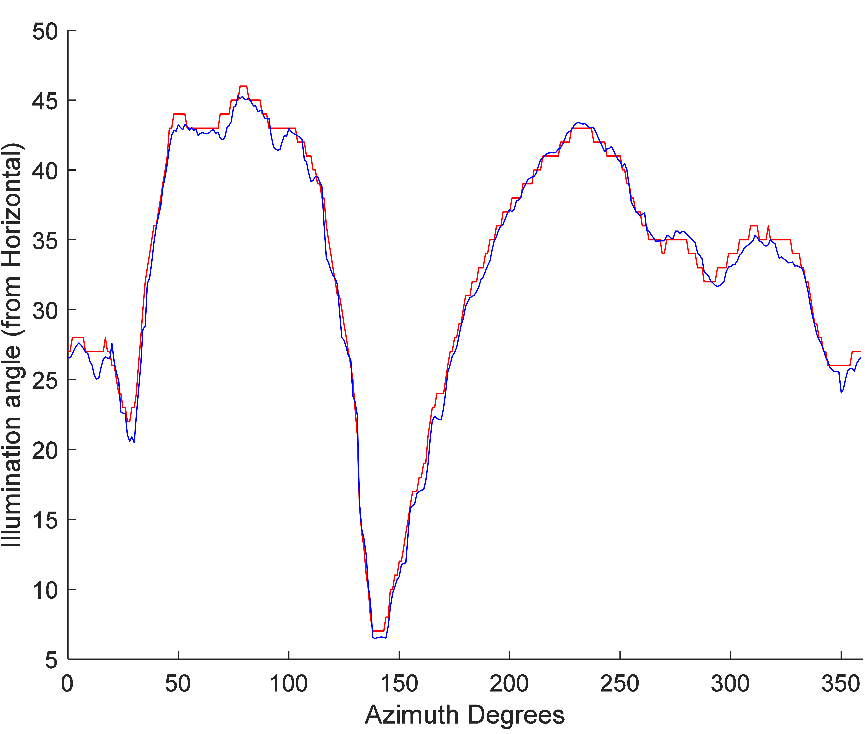

# Figure S11. Comparison of predicted illumination angles 8.1 km upstream from Lees Ferry (i.e., RM -5) using the model presented by Yard et al. (2005) (red line) and the algorithm used here (i.e., Text S2) (blue line). Root mean square error between the two models is 0.884 degrees of illumination angle.

C:\Users\Echo\Documents\ColoradoRiverBasin\Matlab\Colorado_River_Basin\Presentations\GC_temp_model_paper\Supplemental\Historical_comparison\temp_v_PowellElevation.tif

# Figure S12. Historical daily water temperature at Lees Ferry (blue line) and daily elevation at Lake Powell (black line). Start of initial storage is approximately April 13, 1963 and completion of initial filling is approximately June 6, 1980.

# Table S1. Current and historical Colorado River monitoring stations within Grand Canyon in order of river kilometer. Bold font indicates stations that were used in this model.

|  |  |  |  |  |
| --- | --- | --- | --- | --- |
| Name | USGS Gage Name | Approximate river mile (km) | Active? | Parameters |
| Main Channel, Colorado River |  |  |  |  |
| Glen Canyon Dam | 09379901 | -15 (-24.1) | Yes | Water Temperature, \*, †, ‡, |
| at Lees Ferry | 09380000 | 0 (0) | Yes | Flow, Water Temperature, \*, †, ‡, § |
| near river mile 30 | 09383050 | 30 (48.3) | Yes | Flow, Water Temperature, \*, †, ‡, § |
| near river mile 33 | Riv Mi 33 | 33 (53.1) | No | Water Temperature |
| above Little Colorado River | 09383100 | 61 (98.2) | Yes | Flow, Water Temperature, \*, †, ‡, § |
| near river mile 66 | 09402352 | 66 (106.2) | Yes | Water Temperature |
| near river mile 76 | 09402430 | 76 (122.3) | No | Water Temperature |
| near Grand Canyon | 09402500 | 88 (141.6) | Yes | Flow, Water Temperature, \*, †, ‡, § |
| below 127 Mile Creek | 09403270 | 127 (204.4) | Yes | Water Temperature |
| near river mile 132 | Riv Mi 132 | 132 (212.4) | No | Water Temperature |
| near river mile 149 | Riv Mi 149 | 149 (239.8) | No | Water Temperature |
| above National Canyon | 09404120 | 167 (268.8) | Yes | Flow, Water Temperature, \*, †, ‡, § |
| near river mile 194 | Riv Mi 194 | 194 (312.2) | No | Water Temperature |
| above Diamond Creek | 09404200 | 225 (362.1) | Yes | Flow, Water Temperature, \*, †, ‡, § |
| near river mile 246 | 09404220 | 246 (395.9) | Yes | Water Temperature |
| Tributaries |  |  |  |  |
| Paria River | 09382000 | 0.9 (1.4) | Yes | Flow, Water Temperature, § |
| Nankoweap Creek | Nankoweap Ck Mouth | 52.5 (84.5) | No | Water Temperature |
| Little Colorado River | 09402300 | 62 (99.8) | Yes | Flow, Water Temperature, § |
| Bright Angle Creek | 09403000 | 88.4 (142.3) | Yes | Flow, Water Temperature, ‡, § |
| Shinumo Creek | Shinumo Ck | 109.3 (175.9) | No | Water Temperature |
| Tapeats Creek | Tapeats Ck Mouth | 134.4 (216.3) | No | Water Temperature |
| Kanab Creek | 09403850 | 144 (231.7) | Yes | Flow, Water Temperature, ‡, § |
| Havasu Creek | 09404115 | 157.3 (253.1) | Yes | Flow, Water Temperature, ‡, § |

Additional monitoring parameters:

\* Dissolved Oxygen

† Turbidity

‡ Specific Conductance

§ Suspended Sediment (sand, silt, and clay)

# Table S2. Calibrated roughness values for each segment of the Colorado River in Grand Canyon.

|  |  |  |  |
| --- | --- | --- | --- |
| Reach Name | Reach Length miles (km) | Downstream Gage | Roughness |
| Upper Marble Canyon | 30 (48.3) | RM30 | 0.033 |
| Lower Marble Canyon | 31 (49.9) | RM61 | 0.040 |
| Eastern Grand Canyon | 27 (43.5) | RM88 | 0.038 |
| East-Central Grand Canyon | 79 (127.1) | RM167 | 0.040 |
| West-Central Grand Canyon | 58 (93.3) | RM225 | 0.033 |

# Table S3. Comparison of air temperature data from weather stations within Grand Canyon and at Page, AZ. The mean air temperature from within Grand Canyon (excluding Page, AZ and Regressed Air Temperature) is 19.95 °C.

|  |  |  |  |  |  |
| --- | --- | --- | --- | --- | --- |
| Station Name | Sourcea | Years of data | Approximate river mile (km) | Mean air temperature (C) | Mean residual air temperatureb (C) |
| Page Municipal Airport | MesoWest | 21.1 | -15 (-24.1) | 16.03 | -3.73 |
| AZ C:02:0071 | GCMRC | 2.8 | -10 (-16.1) | 16.45 | -0.81 |
| AZ C:02:0070 | GCMRC | 3.6 | 0.5 (0.8) | 17.85 | -2.44 |
| AZ C:05:0031 Upper | GCMRC | 0.2 | 24.5 (39.4) | 20.23 | -0.39 |
| AZ C:05:0031 Lower | GCMRC | 4.4 | 24.5 (39.4) | 19.37 | -0.49 |
| AZ C:13:0365 Upper | GCMRC | 3.5 | 58 (93.3) | 19.49 | 0.48 |
| AZ C:13:0365 Lower | GCMRC | 3.5 | 58 (93.3) | 18.90 | 0.42 |
| AZ C:13:0006 | GCMRC | 4.3 | 60 (96.6) | 19.87 | 0.17 |
| AZ C:13:0336 | GCMRC | 4.4 | 66 (106.2) | 19.80 | 0.73 |
| AZ C:13:0346 Upper | GCMRC | 9.7 | 70 (112.7) | 20.53 | 0.22 |
| AZ C:13:0346 Lower | GCMRC | 4.7 | 70 (112.7) | 19.09 | 0.01 |
| WX7FGZ-1 Phantom Ranch | MesoWest | 7.5 | 88 (141.6) | 20.49 | 0.18 |
| Regressed Air Temperature at Phantom Ranch | Calculated | 21.1 | 88 (141.6) | 19.76 | 0.00 |
| AZ B:10:0225 | GCMRC | 3.7 | 125.5 (202) | 22.75 | 1.60 |
| AZ B:11:0281 | GCMRC | 4.0 | 135 (217.3) | 19.82 | 1.23 |
| AZ A:15:0033 | GCMRC | 4.4 | 203 (326.7) | 21.94 | 2.56 |
| AZ G:03:0072 | GCMRC | 9.8 | 223 (358.9) | 22.75 | 2.80 |

a See Caster et al. (2014) for description of US Geological Survey Grand Canyon Monitoring and Research Center (GCMRC) stations.

b Residual air temperature is observed air temperature minus regressed air temperature at Phantom Ranch.

# Table S4. Remote automated weather station (RAWS) network sites used to aggregate measured shortwave radiation into a hourly median time series (*Jsn,meas*).

|  |  |  |  |  |
| --- | --- | --- | --- | --- |
| SiteCode | Station Name | Latitude | Longitude | Elevation (ft) |
| AZPA3 | AZTCA\_PORT1 | 35.51488 | -113.543 | 4468 |
| QDPA3 | DRY PARK | 36.45308 | -112.238 | 8706 |
| QFSA3 | FOUR SPRINGS | 36.79361 | -112.043 | 6560 |
| FZWA3 | FRAZIER WELLS | 35.84551 | -113.055 | 6796 |
| QGSA3 | GUNSIGHT | 36.70444 | -112.583 | 5280 |
| QLBA3 | LINDBERGH HILL | 36.28556 | -112.079 | 8800 |
| QMLA3 | MOUNT LOGAN | 36.35306 | -113.199 | 7605 |
| QMMA3 | MUSIC MOUNTAIN | 35.61497 | -113.794 | 5375 |
| NVRA3 | NEVERSHINE | 36.24753 | -113.889 | 2165 |
| QNFA3 | NIXON FLATS | 36.38833 | -113.158 | 6500 |
| QOKA3 | OLAF KNOLLS | 36.50722 | -113.816 | 2900 |
| QPPA3 | PARIA POINT | 36.72778 | -111.822 | 7235 |
| TCRA3 | TRUXTON CANYON | 35.78013 | -113.796 | 5304 |
| QTUA3 | TUSAYAN | 35.98833 | -112.121 | 6570 |
| QYJA3 | YELLOW JOHN MOUNTAIN | 36.155 | -113.549 | 6160 |
| QNMA3 | NAVAJO MONUMENT | 36.67692 | -110.541 | 7279 |
| QHIA3 | HOPI | 35.86292 | -110.615 | 5579 |
| KAGU1 | KANE GULCH | 37.52472 | -109.893 | 6500 |

# References

Alvarez, L. V., & Schmeeckle, M. W. (2013). Erosion of river sandbars by diurnal stage fluctuations in the Colorado River in the Marble and Grand Canyons: Full-scale laboratory experiments. River Research and Applications, 29(7), 839–854. https://doi.org/10.1002/rra.2576

Anderson, C. R., & Wright, S. A. (2007). Development and application of a water temperature model for the Colorado River below Glen Canyon Dam, Arizona. Proceedings of the American Institute of Hydrology, 23, 1–11.

Behn, K. E., Kennedy, T. A., & Hall, R. O. J. (2010). Basal resources in backwaters of the Colorado River below Glen Canyon Dam - Effects of discharge regimes and comparison with mainstem depositional environments. U.S. Geological Survey Open-File Report 2010-1075, 25. http://pubs.usgs.gov/of/2010/1075/

Budhu, M., & Gobin, R. (1995). Seepage-induced slope failures on sandbars in Grand Canyon. Journal of Geotechnical Engineering, 121(August), 601–609.

Buendia, C., Sabater, S., Palau, A., Batalla, R. J., & Marcé, R. (2015). Using equilibrium temperature to assess thermal disturbances in rivers. Hydrological Processes, 29(19), 4350–4360. https://doi.org/10.1002/hyp.10489

Caster, J. J., Dealy, T. P., Andrews, T., Fairley, H., Draut, A. E., Sankey, J. B., & Bedford, D. R. (2014). Meteorological data for selected sites along the Colorado River Corridor, Arizona, 2011-2013. U.S. Geological Survey Open-File Report 2014-1247, 56. https://doi.org/http://dx.doi.org/10.3133/ofr20141247

Caster, J. J., & Sankey, J. B. (2016). Variability in rainfall at monitoring stations and derivation of a long-term rainfall intensity record in the Grand Canyon Region, Arizona, USA. In Scientific Investigations Report. https://doi.org/10.3133/sir20165012

Carpenter, M. C., Crosswhite, J. A., & Carruth, R. L. (1995). Water-level fluctuations, water temperatures, and tilts in sandbars -6.5R, 43.1L, and 172.3L, Grand Canyon, Arizona, 1990-93. Open-File Report 94-485, 17.

Draut, A. E., & Rubin, D. M. (2006). Measurements of wind, aeolian sand transport, and precipitation in the Colorado River corridor, Grand Canyon, Arizona; January 2005 to January 2006. In Open-File Report (Revised an). https://doi.org/10.3133/ofr20061188

Edinger, J. E., Duttweiler, D. W., & Geyer, J. C. (1968). The response of water temperatures to meteorological conditions. Water Resources Research. https://doi.org/10.1029/WR004i005p01137

Erbs, D. G., Klein, S. A., & Duffie, J. A. (1982). Estimation of the diffuse radiation fraction for hourly, daily and monthly-average global radiation. Solar Energy. https://doi.org/10.1016/0038-092X(82)90302-4

Ferencz, S. B., Cardenas, M. B., & Neilson, B. T. (2019). Analysis of the effects of dam release properties and ambient groundwater flow on surface water‐groundwater exchange over a 100‐km‐long reach. Water Resources Research, 55(11), 8526–8546. https://doi.org/10.1029/2019WR025210

Ferrari, R. (1987). Colorado River water temperature modeling below Glen Canyon Dam. *Glen Canyon Environmental Studies*.

Garrett, D., Baron, J., Dale, V., Gunderson, L., Hulse, D., Kitchell, J., Loomis, J., Palmer, M., Parker, R., Robertson, D., Schwartz, D., & Watkins, J. (2003). Evaluating a Glen Canyon Dam temperature control device to enhance native fish habitat in the Colorado River: A risk assessment. Upper Colorado Region, Bureau of Reclamation, June.

Graf, J. B. (1995). Measured and Predicted Velocity and Longitudinal Dispersion At Steady and Unsteady-Flow, Colorado River, Glen Canyon Dam To Lake Mead. Water Resources Bulletin, 31(2), 265–281.

Grams, P., Schmidt, J., Wright, S., Topping, D., Melis, T., & Rubin, D. (2015). Building sandbars in the Grand Canyon. Eos, 96. https://doi.org/10.1029/2015EO030349

Hoch, S. W., & David Whiteman, C. (2010). Topographic effects on the surface radiation balance in and around Arizona’s Meteor crater. Journal of Applied Meteorology and Climatology, 49(6), 1114–1128. https://doi.org/10.1175/2010JAMC2353.1

Hoffnagle, T. L. (2001). Changes in water temperature of backwaters during fluctuating vs. short-term steady flows in the Colorado River, Grand Canyon. Proceedings of the Fifth Biennial Conference of Research on the Colorado Plateau, June, 103–118.

Huning, L. S., & Margulis, S. A. (2015). Watershed modeling applications with a modular physically-based and spatially-distributed watershed educational toolbox. Environmental Modelling & Software, 68, 55–69. https://doi.org/10.1016/j.envsoft.2015.02.008

Huntoon, P. W. (1974). The karstic groundwater basins of the Kaibab Plateau, Arizona. Water Resources Research, 10(3), 579–590. https://doi.org/10.1029/WR010i003p00579

Kurylyk, B. L., Moore, R. D., & Macquarrie, K. T. B. (2016). Scientific briefing: Quantifying streambed heat advection associated with groundwater-surface water interactions. Hydrological Processes. https://doi.org/10.1002/hyp.10709

Lam, J. C., & Li, D. H. W. (1996). Correlation between global solar radiation and its direct and diffuse components. Building and Environment, 31(6), 527–535. https://doi.org/10.1016/0360-1323(96)00026-1

Leeder, M. R. (2010). Sedimentology and sedimentary basins: From turbulence to tectonics. *Wiley*.

McMahon, A., & Moore, R. D. (2017). Influence of turbidity and aeration on the albedo of mountain streams. Hydrological Processes, 31(25), 4477–4491. https://doi.org/10.1002/hyp.11370

Matzinger, N., Andretta, M., van Gorsel, E., Vogt, R., Ohmura, A., & Rotach, M. W. (2003). Surface radiation budget in an alpine valley. Quarterly Journal of the Royal Meteorological Society, 129(588), 877–895. https://doi.org/10.1256/qj.02.44

Neilson, B. T., Stevens, D. K., Chapra, S. C., & Bandaragoda, C. (2009). Data collection methodology for dynamic temperature model testing and corroboration. Hydrological Processes, 23(20), 2902–2914. https://doi.org/10.1002/hyp.7381

Orgill, J. F., & Hollands, K. G. T. (1977). Correlation equation for hourly diffuse radiation on a horizontal surface. Solar Energy, 19(4), 357–359. https://doi.org/10.1016/0038-092X(77)90006-8

Petersen, J. H., & Paukert, C. P. (2005). Development of a bioenergetics model for humpback chub and evaluation of water temperature changes in the Grand Canyon, Colorado River. Transactions of the American Fisheries Society, 134(4), 960–974. https://doi.org/10.1577/T04-090.1

Ross, R. P., & Vernieu, W. S. (2013). Nearshore temperature findings for the Colorado River in Grand Canyon, Arizona - Possible implications for native fish. U.S. Geological Survey Fact Sheet 2013–3104. https://doi.org/10.3133/fs20133104

Sabol, T. A., & Springer, A. E. (2013). Transient simulation of groundwater levels within a sandbar of the Colorado River, Marble Canyon, Arizona, 2004. U.S. Geological Survey Open-File Report 2013-1277, 22. https://doi.org/http://dx.doi.org/10.3133/ofr20131277

Schmidt, J. C., Topping, D. J., Rubin, D. M., Hazel, J. E., Kaplinski, M., Wiele, S. M., & Goeking, S. A. (2007). Streamflow and sediment data collected to determine the effects of low summer steady flows and habitual maintenance flows in 2000 on the Colorado River between Lees Ferry and Bright Angel Creek, Arizona. U.S. Geological Survey Open-File Report 2007-1268, 79 p. http://pubs.usgs.gov/of/2007/1268/

Theurer, F. D., Voos, K. A., & Miller, W. J. (1984). Instream water temperature model. Instream Flow Information Paper 16. In FWS/OBS. http://pubs.er.usgs.gov/publication/fwsobs84\_15

Topping, D. J., Rubin, D. M., & Vierra, L. E. (2000). Colorado River sediment transport: 1. Natural sediment supply limitation and the influence of Glen Canyon Dam. Water Resources Research, 36(2), 515–542. https://doi.org/10.1029/1999WR900285

Topping, D. J., Schmidt, J. C., & Vierra Jr., L. E. (2003). Computation and analysis of the instantaneous-discharge record for the Colorado River at Lees Ferry, Arizona : May 8, 1921, through September 30, 2000. In Professional Paper. https://doi.org/10.3133/pp1677

Trammell, M. A., Valdez, R. A., Carothers, S. W., & Ryel, R. J. (2002). Effects of a low steady summer flow experiment on native fishes of the Colorado River in Grand Canyon, Arizona. SWCA Environmental Consultants.

U.S. Bureau of Reclamation. (1999). Glen Canyon Dam modifications to control downstream temperatures - plan and draft environmental assessment. Department of the Interior.

U.S. Department of the Interior. (2007). Recod of decision: Colorado River interim guidelines for lower basin shortages and the coordinated operations for Lake Powell and Lake Mead, Final environmental impact statement. Office of the Secretary of Interior, Washington, D.C.

Valdez, R. A., Speas, D. W., & Kubly, D. M. (2013). Benefits and risks of temperature modification at Glen Canyon Dam to aquatic resources of the Colorado River in the Grand Canyon. U.S. Bureau of Reclamation, Upper Colorado Region, Salt Lake City, UT.

Vernieu, W. S., & Anderson, C. R. (2013). Water temperatures in select nearshore environments of the Colorado River in Grand Canyon, Arizona, during the low steady summer flow experiment of 2000. U.S. Geological Survey Open- File Report 2013–1066, 44.

Vernieu, W. S., Hueftle, S. J., & Gloss, S. P. (2005). Water quality in Lake Powell and the Colorado River. In S. P. Gloss, J. E. Lovich, & T. S. Melis (Eds.), State of the Colorado River Ecosystem (pp. 69–85). U.S. Geological Survey Circular 1282.

Wiele, S. M., & Griffin, E. R. (1997). Modification to a one-dimensional model of unsteady flow in the Colorado River through the Grand Canyon, Arizona. Water-Resouces Investigations Report 97-4046, 17.

Wright, S. A., Anderson, C. R., & Voichick, N. (2009). A simplified water temperature model for the Colorado River below Glen Canyon Dam. River Research and Applications, 25(6), 675–686. https://doi.org/10.1002/rra.1179

Wright, S. A., Melis, T. S., Topping, D. J., & Rubin, D. M. (2005). Influence of Glen Canyon Dam operations on downstream sand resources of the Colorado River in Grand Canyon. In S. P. Gloss, J. E. Lovich, & T. S. Melis (Eds.), State of the Colorado River Ecosystem (pp. 17–31). U.S. Geological Survey Circular 1282.

Yard, M. D., Bennett, G. E., Mietz, S. N., Coggins, L. G., Stevens, L. E., Hueftle, S., & Blinn, D. W. (2005). Influence of topographic complexity on solar insolation estimates for the Colorado River, Grand Canyon, AZ. Ecological Modelling, 183(2–3), 157–172. https://doi.org/10.1016/j.ecolmodel.2004.07.027